Dylan Gallup

CS 260: Object Oriented Programming

Tevis Boulware

CS260 COURSE PROJECT

1. UML Diagram

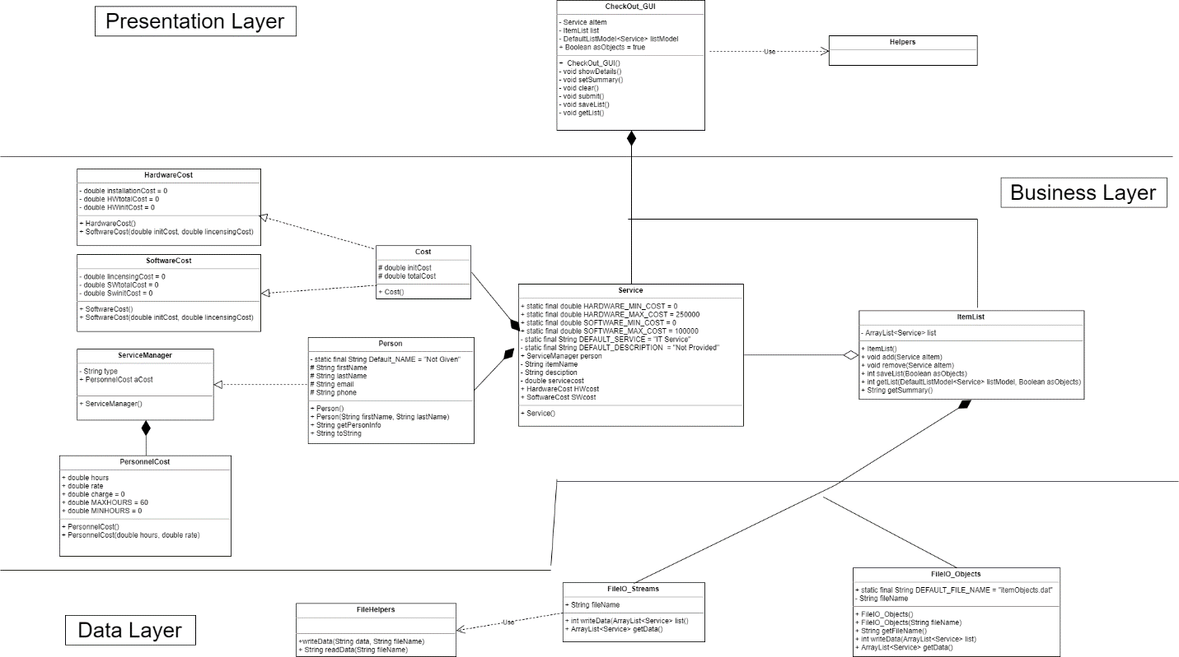

1. Test Conditions

Figure 4: Test Case Scenarios

|  |  |  |  |  |  |
| --- | --- | --- | --- | --- | --- |
| **#** | **Purpose** | **Input Values** | **Expected Results** | **Pass/Fail** | **Comments** |
|  | Check bounds | All valid inputs except  txtFirstName = NULL | Error Prompt to appear | **Pass** |  |
|  | Check bounds | All valid inputs except txtLastName = NULL | Error Prompt to appear | **Pass** |  |
|  | Check bounds | All valid inputs except  txtEmail = dgallup | Error Prompt to appear | **Pass** | Missing the @ tag that is why is appears |
|  | Check bounds | All valid inputs except  txtHours = 7778888 | Error Prompt to appear | **Pass** | Needs 9 numbers not 7 |
|  | Check bounds | All valid inputs except  txtInstall = -1 | Error Prompt to appear | **Pass** |  |
|  | Check bounds | All valid inputs except  TxtHWinitialCost = -1 | Error Prompt to appear | **Pass** |  |
|  | Check Buttons | Check to see if Personnel Type changes pay rate | Changes the value of the previous service | **Pass** |  |
|  | Check Menu Item: Submit | All valid inputs | Saves data to the Service Catalog | **Pass** |  |
|  | Check Jbutton: New | Input in all text fields | Clears all Service text fields | **Pass** |  |
|  | Export Data  (Save List button) | Get a few services recorded | File Should appear in project file | **Pass** |  |
|  | Service List Details | Create a few items, then see the data recorded | All the relevant information to the service should appear | **Pass** |  |